**Lecture Note for Numerical Analysis (8): Advanced Topics on Linear Algebraic Equations**

1. **Banded Matrix**

* **Definition of bandwidth and half-bandwidth**

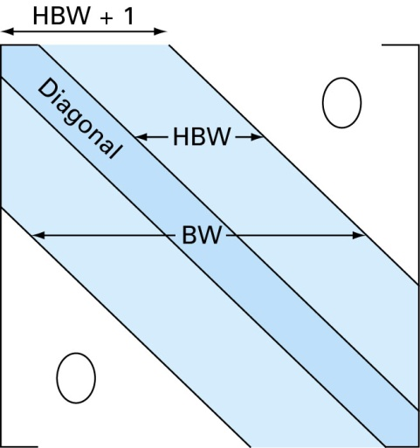

BW: Bandwidth(=2HBW+1)

HBW: Half-bandwidth

* **Example: tridiagonal matrix equation**



* **Example: block tridiagonal matrix equation**



**where** **are matrices and**  **are vectors.**

* **Tomas Algorithm to solve a tridiagonal system using the LU decomposition**



 🡪  🡪 If we can use the same memory, 

**Forward Substitution**



**Back Substitution**





**In case we use the same memory b for x,y**

Forward substitution: 

Back substitution: 

* **Example #1 : Linear Algebraic Equations with Block Upper Triangular Matrix**

 

* **Example #2 : Linear Algebraic Equations with Block Tri-diagonal Matrix**

 



The E2 has been eliminated. Using the same process, matrices E3 and E4 can be removed to get a block upper triangular matrix, which is easily solvable using the result of Example #1.

1. **Symmetric Matrix and Cholesky Decomposition**

* **Definition of Matrix Transpose and Matrix Symmetricity**

**🡪 Transpose of**  **=**

If  , 

A is a symmetric matrix iff  for all i,j

* **Transpose of Matrix Product** ,



* **Cholesky Decomposition: LLT or UTU decomposition for the nonsingular symmetric matrix**



 🡪 since A is a symmetric matrix 🡪

Above matrix can be uniquely factorized with 





* **LDU (for symmetric matrix LDLT) decomposition**



1. **Iterative method Example: Gauss-Seidel/Jacobi Method (poor convergence)**

 **🡪** **🡪** 

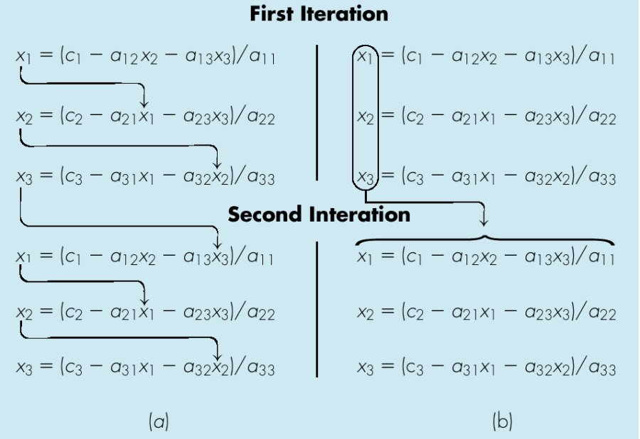

1. **Gauss-Seidel Method (b) Jacobi Method**
2. **Determinants of a Matrix**

**(4-1) Definition of permutation, its degree, the number of inversion and even-odd classification**

* A permutation of degree n is any rearrangement of the first n integers. For simplicity a permutation of degree n can be represented by a n-vector such as.
* The number of inversion in a permutation is the number of instances an integer proceeds a smaller one.
* A permutation is said to be even or odd, depending on whether the number of inversions in is even or odd.

**[Example #1]**

 

  

 

  

**[Example #2]**



7 proceeds 2,6,3,4,1,5 giving 6 inversions

2 proceeds 1 giving 1 inversions

6 proceeds 3,4,1,5 giving 4 inversions

3 proceeds 1 giving 1 inversions

4 proceeds 1 giving 1 inversions

Hence has altogether 13 inversions 🡪 The permutation is odd (= -1)

**(4-2) Definitions of the determinant**

For a matrix  , the determinant of  is denoted with and defined by

)

Where the sum is taken all permutation of degree n, and  is 1 or -1, depending on whether is even or odd.

**[Example #1]**

For n=1 

For n=2 

For n=3 

**[Example #2] Determinant of a upper-(or lower) triangular matrix**



**[Example #3] Determinant of an identity matrix**



**[Example #4] Determinant of a permutation matrix**

In caseis defined by a permutation vector.

= 1 for an even permutation.

=-1 for an odd permutation.

**[Example #5] Determinant of a matrix after the interchange of two columns (or two rows)**

, 

**[Example #6] Determinant of a matrix after one column of** **is** **multiplied by a scalar** 



**[Example #7] For the following three matrices, which have only one different column such as**

 and  

**[Theorem 1] For two matrices**  **,** **is hold.**

**[Theorem 2] Cramer’s Rule: For****, satisfying** **with****and** , **the following relation is hold.**

🡪

1. **Eigenvalue Problem**

**(5-1) Problem Statement**

* Find the (real or complex) number , satisfying for a non zero vector .

We can rewrite the given equation as



**(5-2) Lemma #1: T**he (real or complex) number  is an eigenvaue for the matrixiff (if and only if) is not invertible, which means .

**(5-3) Some Important Properties**

* Eigenvalue of a inverse matrix

.

Therefore, and by comparing with, we can conclude



🡪 The two matrices have the same eigenvectors but the eigenvalue of the inverse matrix is the reciprocal of that of the given matrix

* Scalar multiples of an eigenvector are also eigenvectors.

Let be an eigenvector satisfying  for a given eigenvalue.

Then, for any scalar multiple of  such as , the following relation is hold.

Therefore,  is an eigenvector corresponding to the given eigenvalue.

* Property of vector sequences : Power method

Let’s consider a vector sequence such as .

If we have all pairs of eigenvalues and eigenvector for a matrix , satisfying , then any vector  can be represented by a linear combination of  in the n-dimensional vector space as



Or by using above results for scalar multiple of an eigenvector, we can generally rewrite with



Then,



If we select each eigenvalue with proper ordering in its magnitude such as

 and with further assumption of 

Then



Therefore,

🡪

If we define a sequence of a unit vector , the  converges to  (an

eigenvector) for a large *k.*

Therefore, we can define a ratio if 

🡪 which is called the Rayleigh quotient for and 

* Using with of eigenvalues and eigenvector for a matrix 

 where 

🡪 

🡪  and 

* Using Gauss-Jordan elimination operator , an eigenvalue problem, , can be transformed into



where 

Since 



**Appendix A: Solution of Block-Tridiagonal System of Equations**



**(A-1) Block LU-decomposition**



**Therefore,**





**Remark) Solve  using** 

**Don’t try to get the matrix inverse  and multiply it with** 

(in order to get)**(A-2) Matrix Inversion of Lower Block: Forward Substitution**







**Remark) Solve .**

**Don’t try to get the matrix inverse  and to multiply it with residual** 

**(A-3) Matrix Inversion of Upper Block: Backward Substitution**





**(A-4) Combined Algorithm of (1)+(2)+(3)**

1. 
2. 
3. 

**STEP 1) : (1) + (2)**

**For j = 1**



**For j = 2,…..,N**



**STEP 2) : (3)**



**Appendix B: Inverse of the symmetric positive definite matrix using Cholesky decomposition**

**(B-1) Matrix Structure**









**(B-2) Recurrence Formula for Cholesky Decomposition**

1. j = 1



1. j = 2



1. j = 3



1. For general j up to j = N -1



1. j = N



**(B-3) Matrix Inverse after Cholesky Decomposition**



**Let** 



**Let**



**Where**

** and **

**In other expression with** 



**For j = 1**



**For j = 2**



**For general j**







**Appendix C: Memory Allocation and Operations for the Sparse Matrix**

**(C-1) Memory Allocation scheme: Compressed Sparse Row(CSR) Format**

**Definition of sparse matrix: A matrix which has very few nonzero elements, where the zero elements need not**

**be stored**

**[Example] 12 nonzero elements among 25 elements**



: 12 real variable sequences ordered first in row

: column numbers of nonzero element (integer)

: sequence number of the first nonzero elements at each row

**🡪 **

**(C-2) Basic matrix operation: the matrix A is in the CSR format**

1. 

For j=1:n

k1 = IA(j)

k2 = IA(j+1)-1

y(j) = DOTPRODUCT(A(k1:k2),x(JA(k1:k2));🡨 dot product of two vectors

End

1. Solution of a unit lower triangular system 

**: the matrix L is in the CSR format**

x(1)= y(1)

for j=1:n

k1 = IL(j)

k2 = IL(j+1)-1

x(j) = y(j)-DOTPRODUCT(L(k1:k2),x(JL(k1:k2));🡨 dot product of two vectors

End